**Daily Scrum or Standup Meeting**

Team name: 5th Element

Scrum Master: Leonardo Craven

Date: November 11, 2021

| **Team Member** | **What did you do since the last scrum?** | **What do you plan to do before the next scrum?** | **What obstacles do you have?** |
| --- | --- | --- | --- |
| Leo | Worked on notifications | Add links to scorecard and leaderboard pages (because we forgot)  Finish notifications page (done today) | None |
| Gavin | Worked on order drinks page | Work on order drinks page (done Friday) | None |
| Andrew (not present at meeting, work) | Worked on navigation sidebar | Work on UI design improvements | None |
| Brock | Finish support for money accounts when sponsoring a tournament | Finish migration for company account | None |

# Burndown

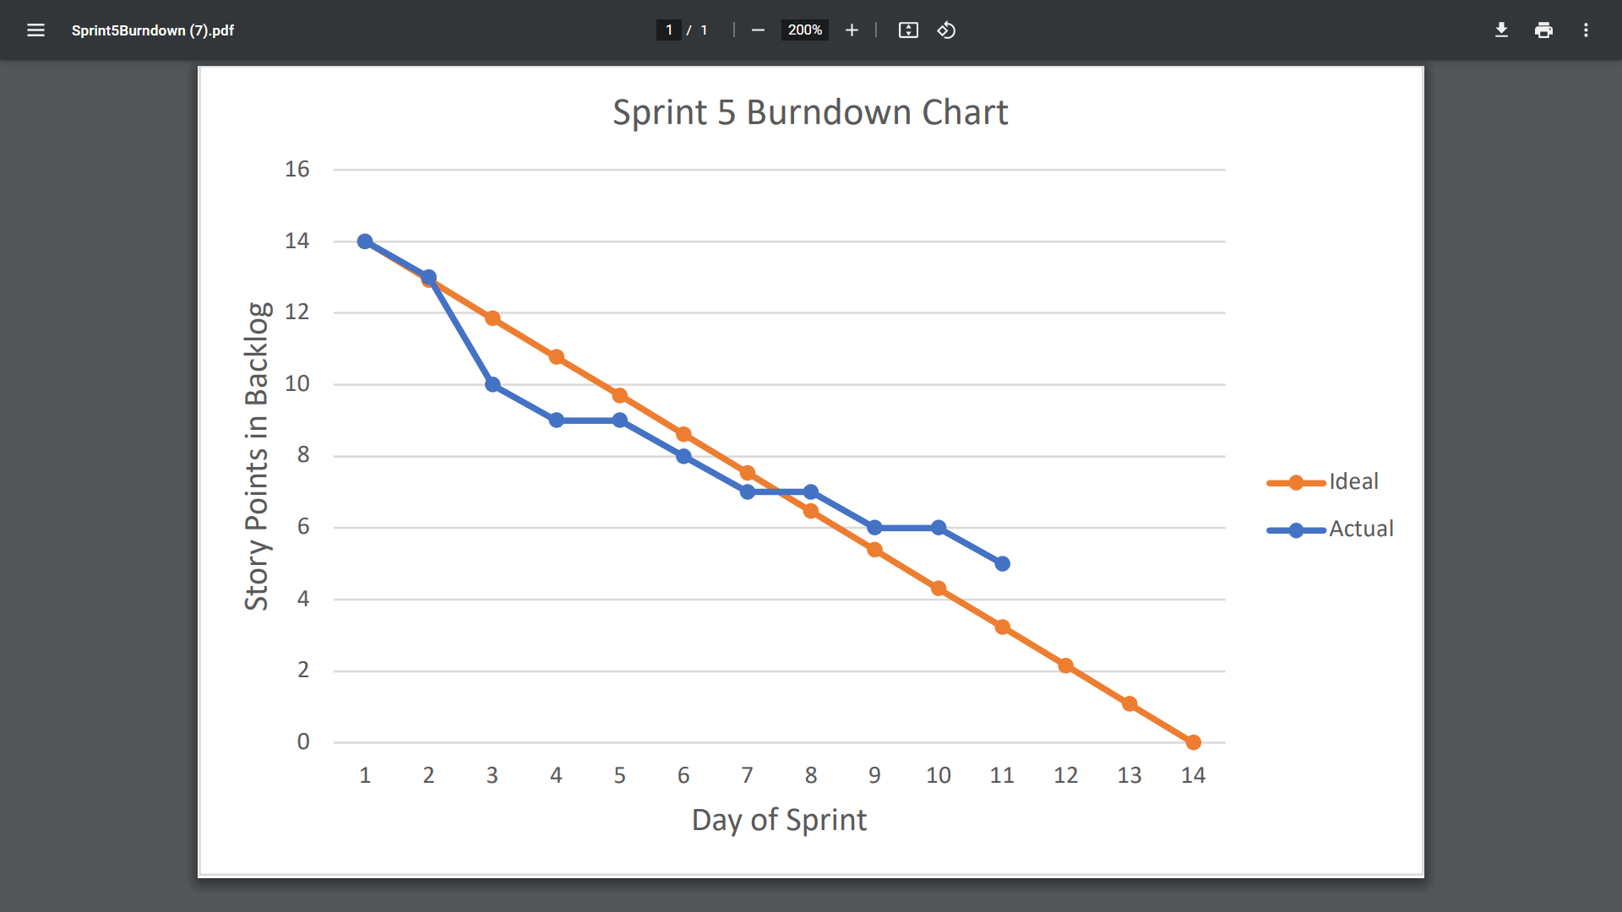

# Screenshot of you project board

